Our Usability Testing Approach

Our Usability testing started with actually understanding what our user experience should look like. We began by envisioning the users, their needs and what they value. For this project, we focused on five of the seven Peter Morville’s user experience Honeycomb attributes, namely, useful, usable, valuable, findable, and credible.

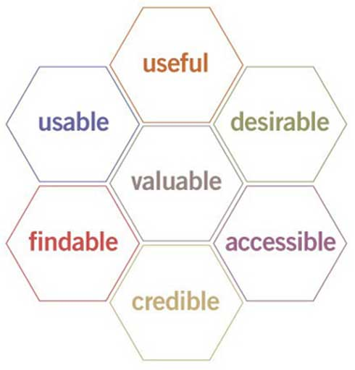In order to build the user experience, we utilized the following disciplines:

* **[User Research](http://www.usability.gov/what-and-why/user-research.html)** - We focused on user behaviors, needs, and motivations through individual and focused group interviews, personas and user feedback.
* [**Usability Evaluation**](http://www.usability.gov/what-and-why/usability-evaluation.html) –We asked questions and obtained feedback on whether our application met their needs and how satisfied they were during user testing. We asked questions on how easy it was to navigate, and the efficiency of use and memorability (can they remember how to use the application after one try).
* [**User Interface Design**](http://www.usability.gov/what-and-why/user-interface-design.html) - Our business analysis team analyzed and anticipated how users might work with the application and with the use of wire frames ensured the elements were easy to access, understand, and use in order to facilitate those actions. We were able to validate and invalidate during user testing.

Source: usability.gov

* [**Visual Design**](http://www.usability.gov/what-and-why/visual-design.html) – We focused on creating an aesthetically pleasing interface that is consistent with Cambria’s branding.

For our Usability testing, our representative users became our testers. These testers were located in different geographical places and utilized different platforms (desktop, cell phone and tablets, various browsers). We collected feedback from them and noted enhancements as issues for every Sprint. We focused on their responses to the following questions:

* Were they able to complete specified tasks successfully?
* Did it take them a satisfactory amount of time to complete the tasks?
* Were they satisfied with the build (application)?

From the usability evaluations and user testing sessions, the business team was then able to evaluate the usability of the application and recommend improvements.

The development team worked on successive sprints to implement the recommendations that were approved by our Product Owner. Except for the first sprint, every sprint included user testing of new functionality, as well as elements and enhancements requested (re-test the application) based on testing from the previous sprint.